**Barcalounge**

Website: <https://www.barcalounger.com/>

#01

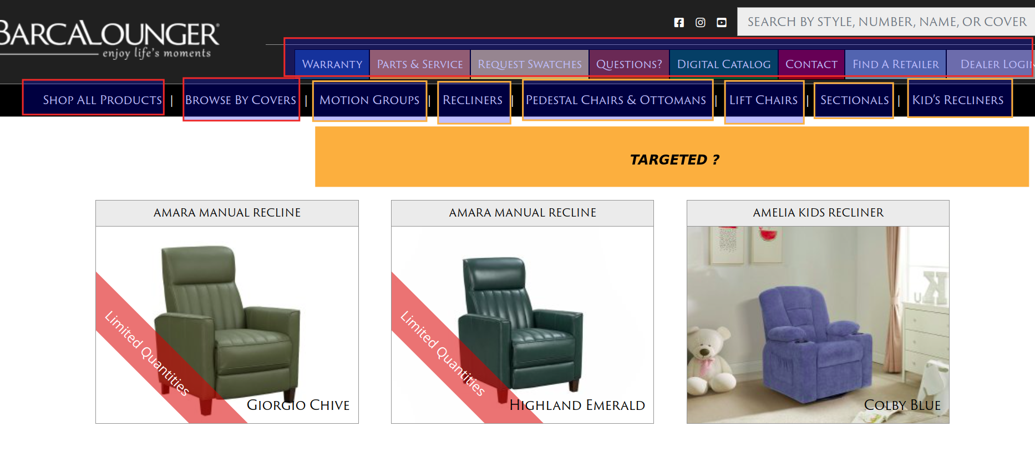

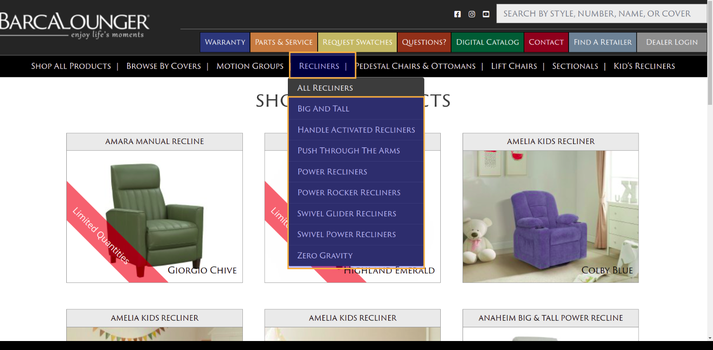

Response : Yes, target items highlighted in yellow per top nav.

#02

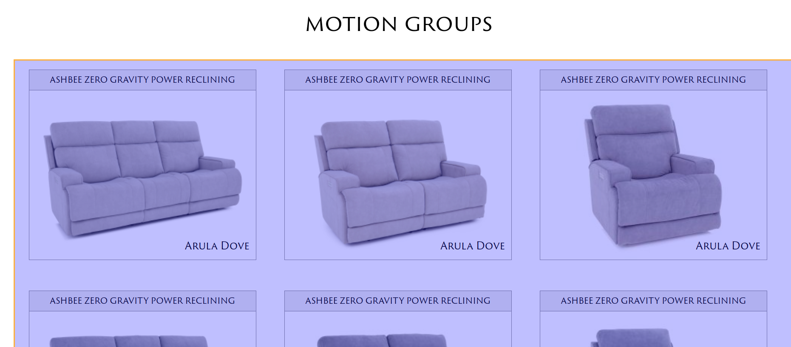

Response: Yes, pull each item displayed on main browser page.

#03

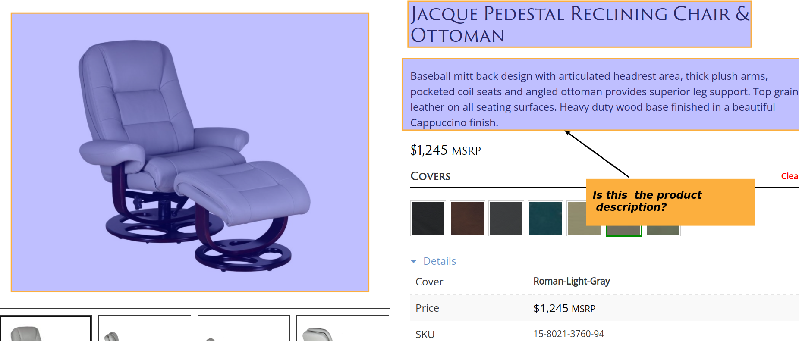

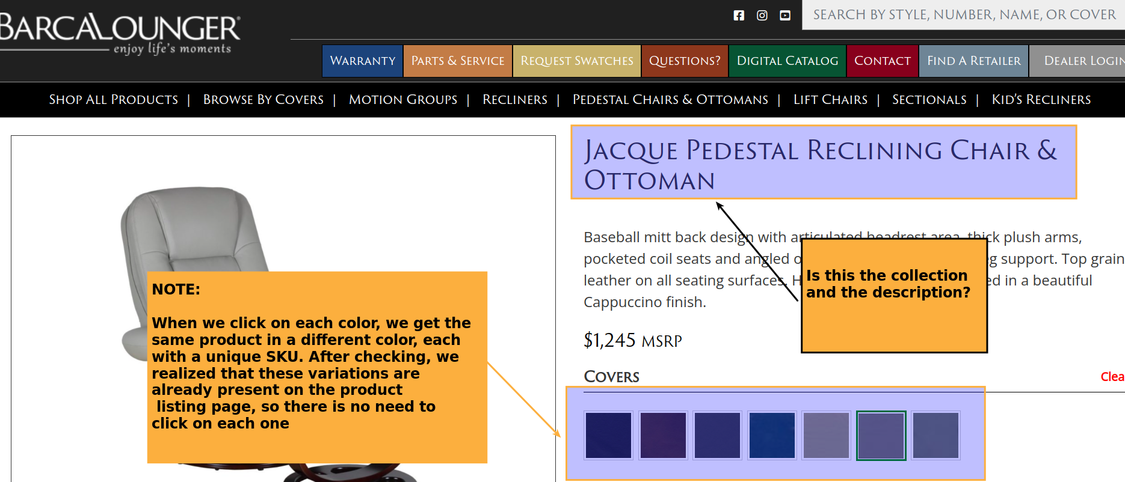

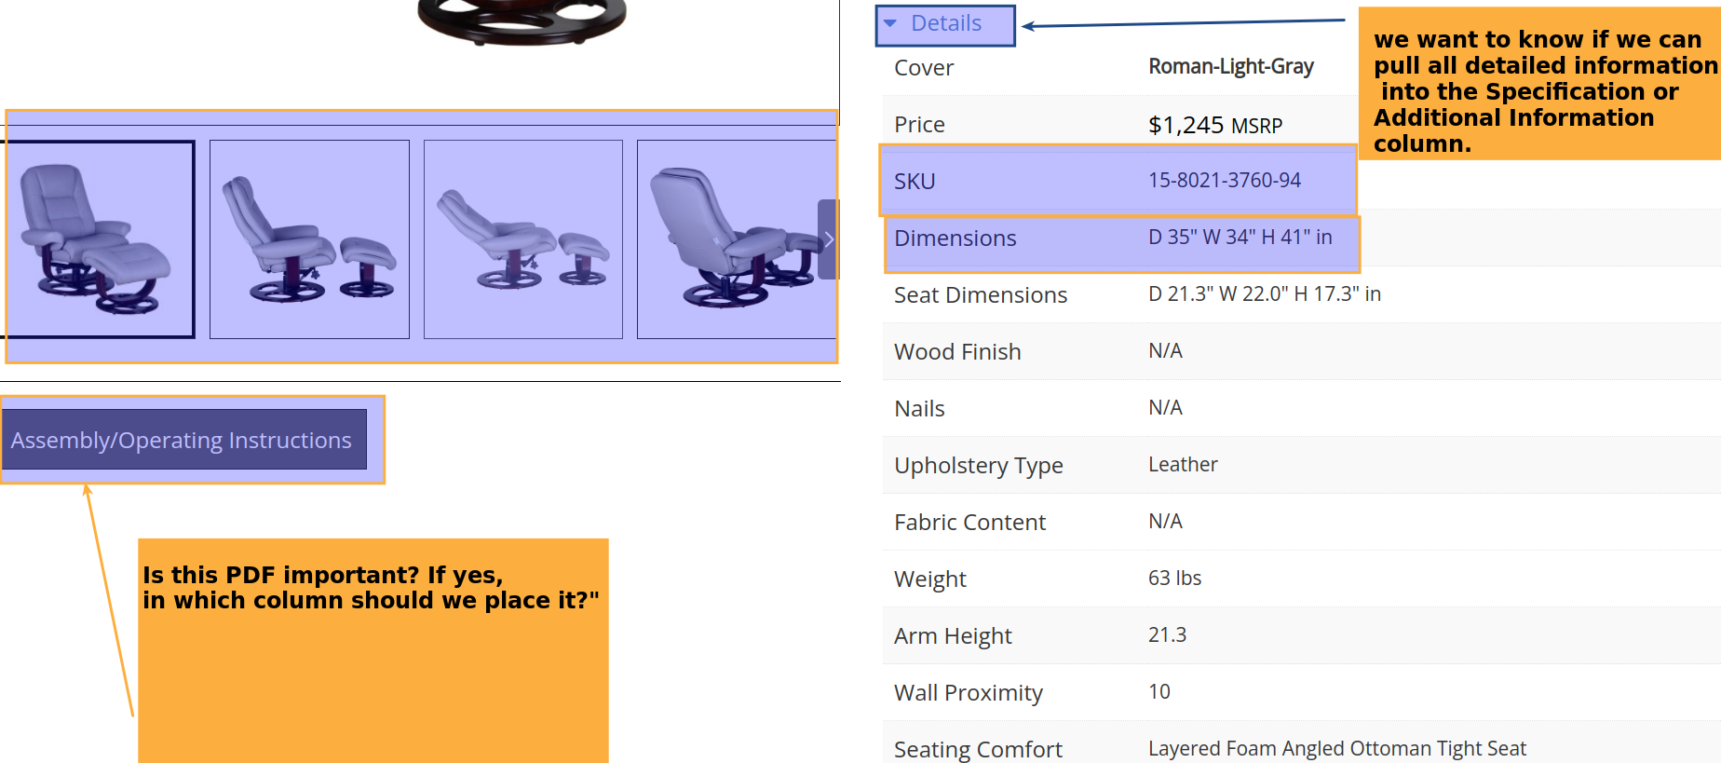

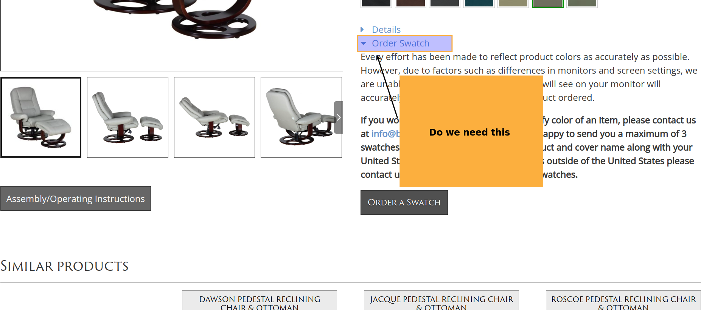  
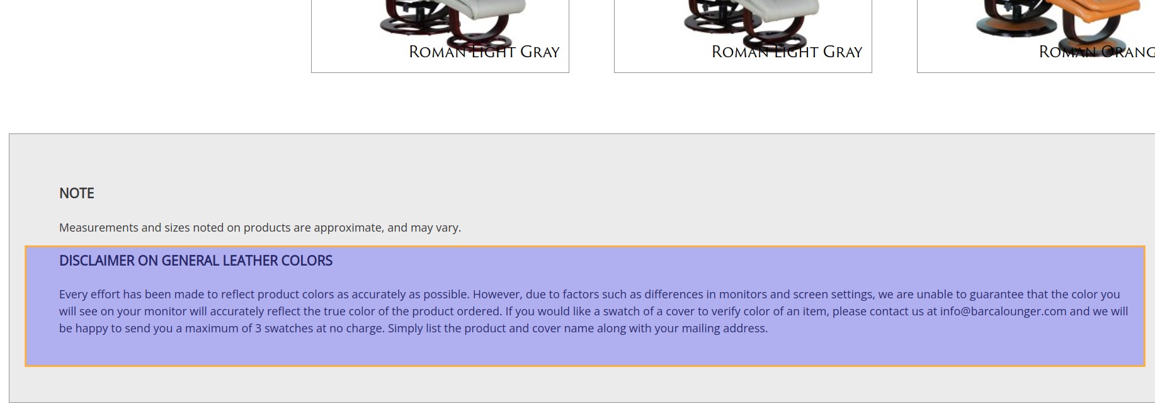

Product link : <https://www.barcalounger.com/view-all-options/jacque?attribute_pa_covers=roman-light-gray>

Please confirm if the information in yellow is correct and relevant.

Response: Yes, the information you have highlighted is correct. For Details, we do have separate columns for Sku, Dimensions, Weight and Arm Height, but all other info (excluding the price, no need to pull this) can be input in Specs and Additional info. We do not need to pull “Order Swatch”. If you can pull the Assembly Instructions pdf. We can attach it under column Info 1 in the data template. We also have a comment field to support Disclaimer info.

#04

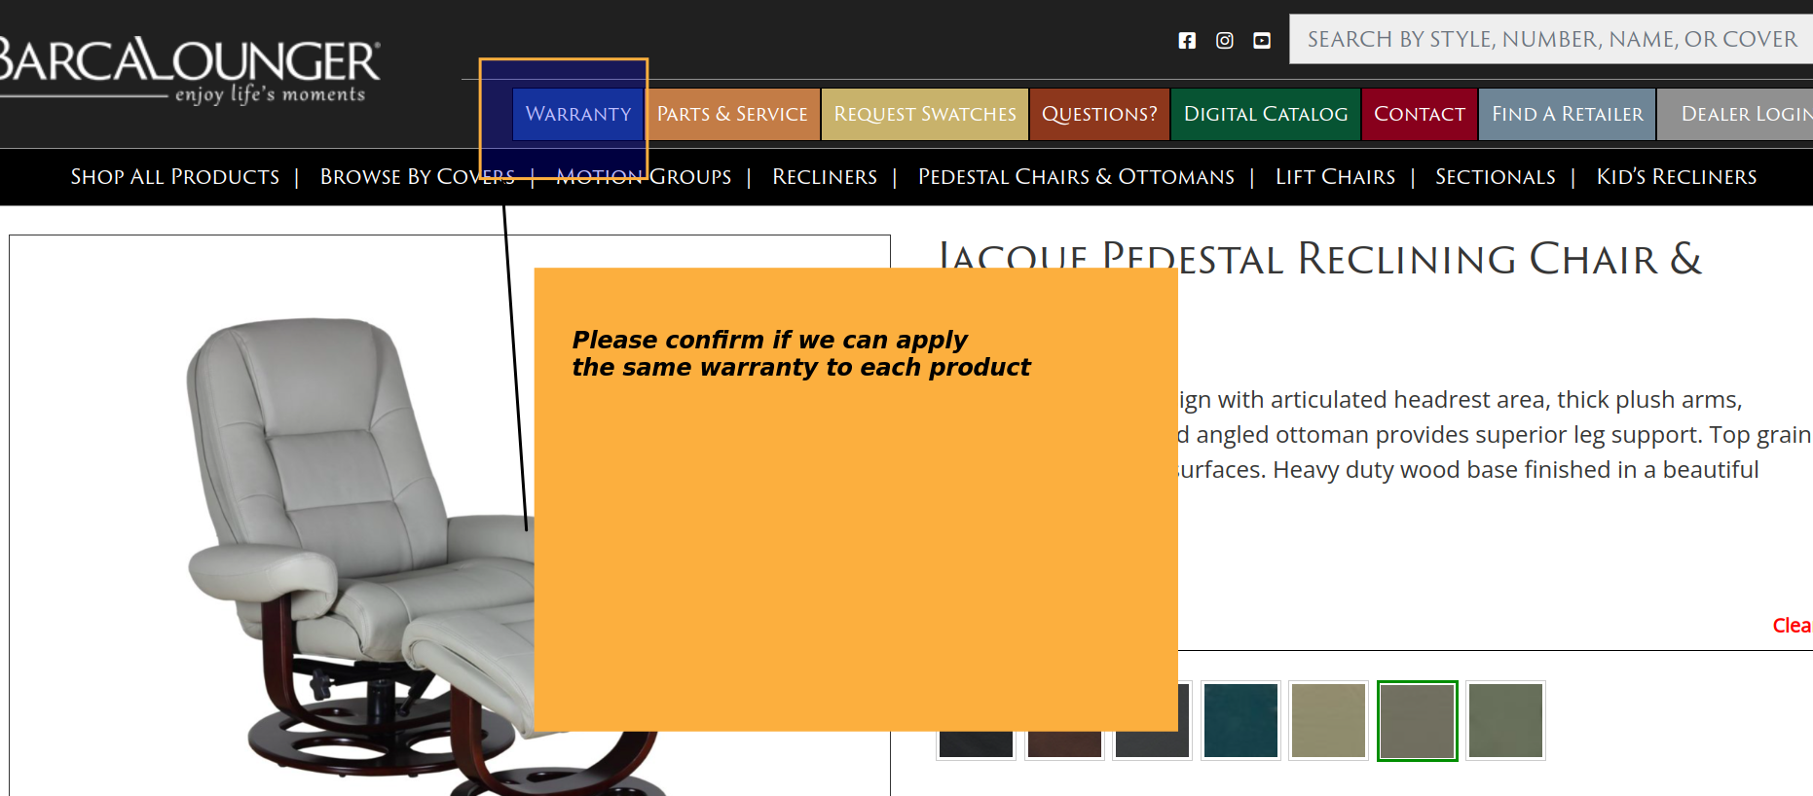

Response : Yes, we should be able to apply a Warranty to overall items.